Software Automation Engineering Team

Desk Procedure for Downloading, Installing & Configuring Powershell

Document Owner: Richard M. Williams

Editor: Richard M. Williams
Document name: Desk Procedure for Downloading and Installing Powershell.doc
Document Revision Number: v3.6
Date: 04-12-17
Document Status: Complete

Version Control
Version | Date | Author | Changes
1.0 | 8-27-2014 | Richard M. Williams | Original Version
1.1 | 10-02-2014 | Richard M. Williams | Added a note under step # 7  Note: Windows 2003 servers require the HTTP SSL service to be running before you can enable the WIRM feature.
1.2 | 10-02-2014 | Richard M. Williams | Added an Appendix A section which outlines how to use scripts for some of the remediation effort.
1.3 | 10-20-2014 | Richard M. Williams | Removed Appendix A section as I was just informed we are not allowed to use psexec in our scripts.
1.4 | 11/13/14 | Richard M. Williams | Updated the notes section on step #8 regarding port 5985 and port 5986
1.5 | 11/14/14 | Richard M. Williams | Added notes for checking if you are an admin on last page.

1.6 | 11/19/14 | Richard M. Williams | Modified the command on step #10 for changing the powershell memory setting.
1.7 | 03/05/15 | Richard M. Williams | Added the following command to the troubleshooting section...2_Set-Item WSMan:\localhost\Client\TrustedHosts -value *

1.8 | 03/06/15 | Richard M. Williams | Provided an updated snapshot in step#10 for the memory change setting
1.9 | 03/23/15 | Richard M. Williams | Added more troubleshooting steps for endpoints that are having connection issues.
2.0 | 4/29/15 | Richard M. Williams | Added more troubleshooting steps for endpoints – i.e. enable-psremoting and get-pssessionconfiguration
2.1 | 5/22/15 | Richard M. Williams | Added step #8 in the troubleshooting steps. This step walks the SA through how to execute a remote powershell connection in order to troubleshoot failed logins.
2.2 | 08/24/15 | Richard M. Williams | Added step #9 in the troubleshooting steps. This step walks the SA through registering powershell via the following command....”Register-PSSessionConfiguration -Name Microsoft.PowerShell”.
2.3 | 08/25/15 | Richard M. Williams | Added step #10 in the troubleshooting section....For those servers not passing the port 5985 test but have remote management enabled, try restarting the Winmgmt service.
2.4 | 08/26/15 | Richard M. Williams | Added a reference section with various links
2.5 | 09/03/15 | Richard M. Williams | Added step #11 troubleshooting step - Error Unknown security using Remote PSSession CredSSP – see the setspn.exe suggestions at the bottom of the link below.
2.6 | 09/22/15 | Richard M. Williams | Added another troubleshooting step for access denied issues. This is a registry tweak added as step#12. Also added step#13 for ipremote proxy errors.
2.7 | 09/29/15 | Richard M. Williams | Added another troubleshooting step – step #14.

2.8 | 11/3/15 | Richard M. Williams | Added another troubleshooting step- step #15 - for adding additional parameters in the connection profile.
2.9 | 11/5/15 | Richard M. Williams | Added another troubleshooting step - step #16 - for modifying the ip address that is listening on WINRM
3.0 | 02/01/2016 | Richard M. Williams | Added additional troubleshooting step – step #17.
3.1 | 02/16/2016 | Richard M. Williams | Updated the troubleshooting section – noting what commands are powershell commands and what ones are DOS commands
3.2 | 03/16/2016 | Richard M. Williams | Added another troubleshooting step – step #18 for WMI call issues.
3.3 | 04/27/2016 | Richard M. Williams | Added another step in TS# 18 – restart the WMI service.
3.4 | 4/29/2016 | Richard M. Williams | Replaced powershell print screen with DOS print screen in step #10.
3.5 | 5/26/2016 | Richard M. Williams | Replaced the verbiage in step#15 to indicate this should only be used for testing purposes – not a permanent connection profile setting.
3.6 | 4/12/2017 | Richard M. Williams | Added an additional troubleshooting step for Group Policies that prevent powershell remote connections.

DESK PROCEDURE FOR DOWNLOADING & INSTALLING POWERSHELL:

- download the correct version of powershell at the link below (version 2 is the lowest level that should be installed)….
http://support.microsoft.com/kb/968929

Prior to downloading, you can verify if Powershell is
installed already with version 2.0 or higher by using the
commands depicted below. From a command prompt,
the following commands can be run in order to validate that
powershell is installed and to confirm the version#
powershell

$PSVersionTable.PSVersion
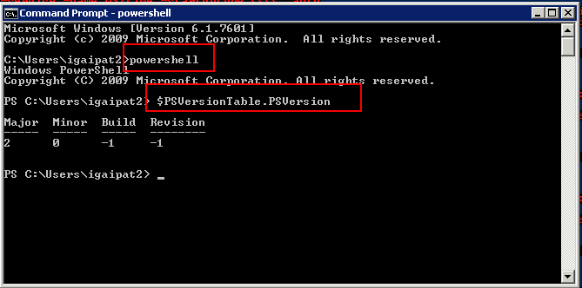

- choose the correct windows 2003 version (2008 should be installed by default) & then begin the download of “windows management framework”.

- before installing, ensure the 2003 server in question has sp2 installed.

- After the installation is complete, you should find Powershell installed under….START \ PROGRAMS \ ACCESSORIES \ WINDOWS POWERSHELL \ WINDOWS POWERSHELL

- These last few steps may apply to 2008 servers as well. Launch the WINDOWS POWERSHELL console (path noted in step above). Right-click on the program name and select the “Run-as administrator” option.

- Check the “winrm” service and ensure the startup is set to “manual” or “auto”.
Get-wmiobject -query "select startmode from win32_service where name='winrm'"
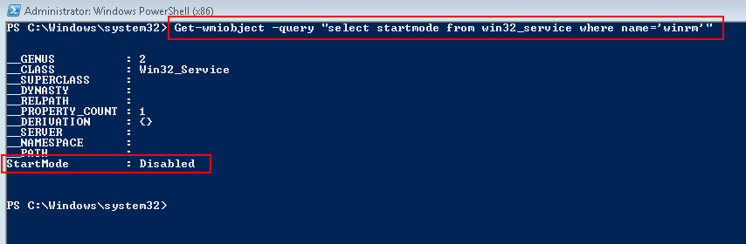

If the startmode is listed as disabled,
set-service winrm -startuptype "automatic"

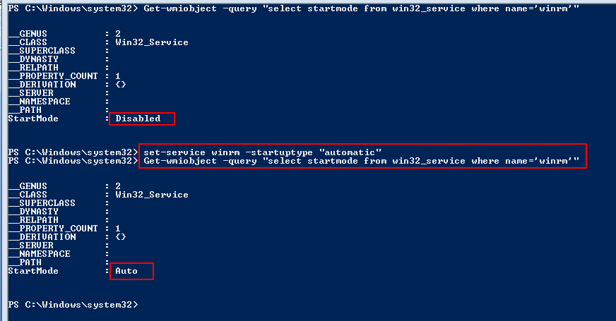

- Next, in order to enable Remote Management, run the following command….
Enable-PSRemoting (answer YES TO ALL or answer YES to each individual question).
Note: Windows 2003 servers require the HTTP SSL service to be running before you can enable the WIRM feature.
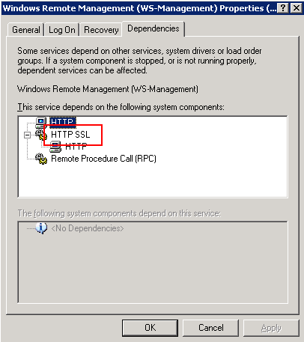

8) The following command can then be run to ensure that
Remote Managment is enabled.
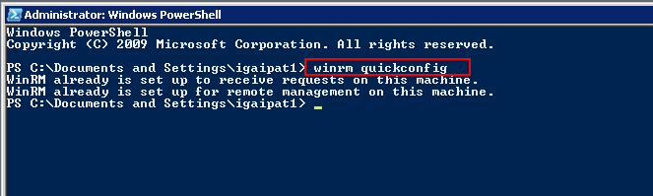
WINRM QUICKCONFIG

After Powershell Remote Management has been enabled the
following Network port, 5985, will then be opened. (Note: Port
5986 is also listed below, as an option, but it would only be
used if the customer wants a “https” connection. In order for
port 5986 to be open and listening, it would require certificate
based authentication. For a successful Ipsoft connection using
“http”, only port 5985 should be required.)

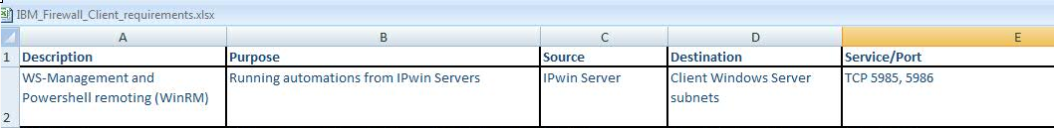

9) From a command prompt, ensure that powershell has at least 512 memory assigned to it. To query this setting run the following command:
winrm get winrm/config/winrs
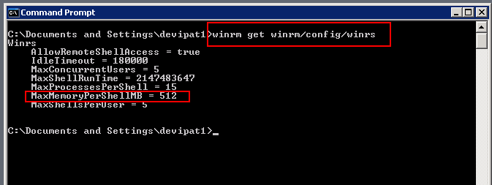

- To change this setting to use 512MB of memory, run the following DOS command:
winrm set winrm/config/winrs '@{MaxMemoryPerShellMB="512"}'
if it errors out remove the single quotes..
winrm set winrm/config/winrs @{MaxMemoryPerShellMB="512"}

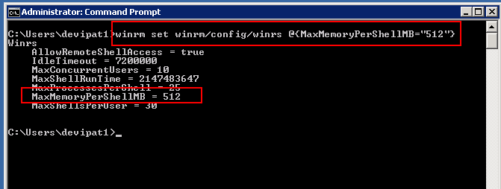

TROUBLESHOOTING:

If you encounter “access denied” issues when trying to execute the “Enable-PSRemoting” and\or “WINRM QUICKCONFIG” commands, then you may need to add the noted registry key from the powershell console – see step#1 below.

Now you’ll need to configure your client machine. First you’ll have to enable WinRM local access so that you can modify the proper settings. To do this, start the WinRM service and enable the local account token filter policy (see this Microsoft support article for details on this machine-wide policy). Run these commands in an elevated PowerShell prompt (this may need to be done on both the ipwin server and on some of the windows endpoints that have access issues):

NOTE: Please ensure the endpoint Active Directory ID(s) and\or Local ID(s) are NOT locked out or disabled. Also, confirm that the Ids are NOT set to prompt for a password reset. Finally, ensure that the AD ID(s) or LOCAL ID(s) have local administrator rights. For Local Ids, the passwords must be in synch.

1_ Disable UAC remote restrictions: Ensure the WINRM service is started and running and ensure the registry setting is in place. Copy and paste this single command into an elevated powershell session. This command disables UAC remote restrictions:
Set-ItemProperty –Path HKLM:\SOFTWARE\Microsoft\Windows\CurrentVersion\Policies\System –Name LocalAccountTokenFilterPolicy –Value 1 –Type DWord
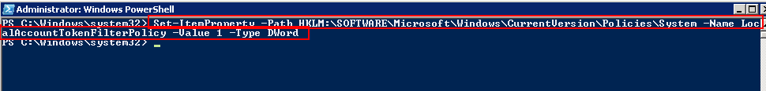
https://support.microsoft.com/en-us/kb/951016

2_Enable trustedhosts. In many cases, we will be able to work with remote computers in other domains. However, if the remote computer is not in a trusted domain, the remote computer might not be able to authenticate our credentials. To enable authentication, you need to add the remote computer to the list of trusted hosts for the local computer in WinRM. To do so, Copy and paste the powershsell command below.
Set-Item WSMan:\localhost\Client\TrustedHosts -value * -force
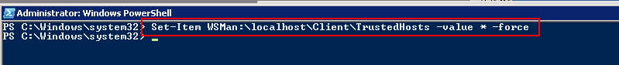
https://technet.microsoft.com/en-us/magazine/ff700227.aspx

3_from a powerhsell prompt, Enable-PSRemoting -force again. This seems to fix some ID access issues.
Enable-PSRemoting -force
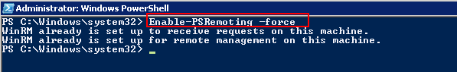
http://blogs.msdn.com/b/wmi/archive/2009/07/24/powershell-remoting-between-two-workgroup-machines.aspx

4_To validate if you are have administrator privileges, copy the command below into a Powershell prompt. If it comes back with a TRUE then you have administrator rights.
$wid=[System.Security.Principal.WindowsIdentity]::GetCurrent();$prp=new-object System.Security.Principal.WindowsPrincipal($wid);$adm=[System.Security.Principal.WindowsBuiltInRole]::Administrator;$IsAdmin=$prp.IsInRole($adm);$isadmin;
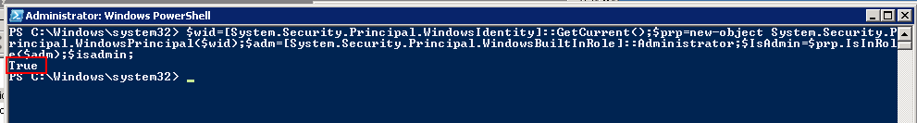

5_ Have the SA run this command on all of their ipwin server(s).
Set-Item WSMan:\localhost\Client\TrustedHosts -value * -force

6_on the endpoint, have the SA check and ensure the server has a local administrator group and, if so, ensure our domain ID is a member of this group. If there is no local administrator group, then this server is possibly a domain controller. Unless we have domain admin rights, we will not be able to access this server.
A_click on START \ CONTROL PANEL \ ADMINISTATOR TOOLS \ COMPUTER MANAGEMENT
B_ click on the “+” to expand the local users and groups
C_ click on the groups
D_ click on the administrators group
E_ ensure our VE AD ID is a member of this group

7_ From powershell, run the “Get-PSSessionConfiguration” command and ensure the correct access is displayed.
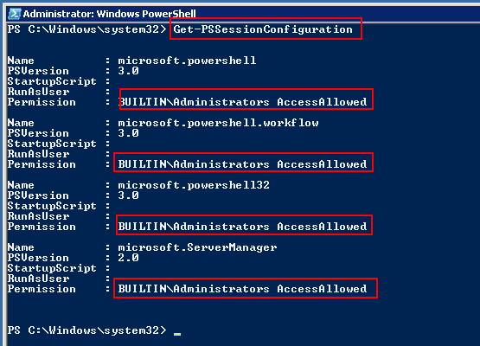

8_Powershell Commands for REMOTE SESSIONS - try these commands from the ipwin server to the target server(s) in question.
A) set the userid (in the example below its “abcipat1” for the target host)
$mycreds="abcipat1"
B) connect to target host (in this example its 9.37.141.150 - you will be prompted for pw)
$session_id=new-pssession -computername 9.37.141.150 -credential $mycreds
C) now test pssession by getting the target hosts hostname
Invoke-Command -Session $session_id -ScriptBlock {hostname}
D) remove session
Remove-PSSession $session_id

9_For servers experiencing the following error below, click on the link below and execute the associated powershell commands:
The WS-Management service cannot process the request.
Cannot find the Microsoft.PowerShell session configuration in the WSMan: drive on the MACHINENAME computer.
Register-PSSessionConfiguration -Name Microsoft.PowerShell
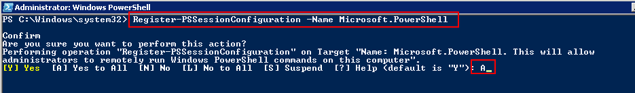
get-PSSessionConfiguration
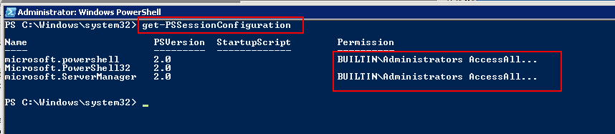
https://thwack.solarwinds.com/thread/62896

10_For those servers not passing the port 5985 test but have remote management enabled, try restarting the “Windows Management Instrumentation” service. The short name for this service is called... “Winmgmt”. Also, try restarting the “Windows Remote Management (WS-Management)” service. The short name for this server is called “WINRM”. If the server still fails, have the DM check with the network team to ensure there are no firewalls between the ipwin server(s) and the endpoint(s). The SA can open an elevated DOS command and ensure the port is listening ….
netstat -an | find “5985”. If the server is listening on that port and there are NO firewall issues, then the DM should also work with the SA to ensure\verify that they have the correct server ip address(es) and fqdn(s).

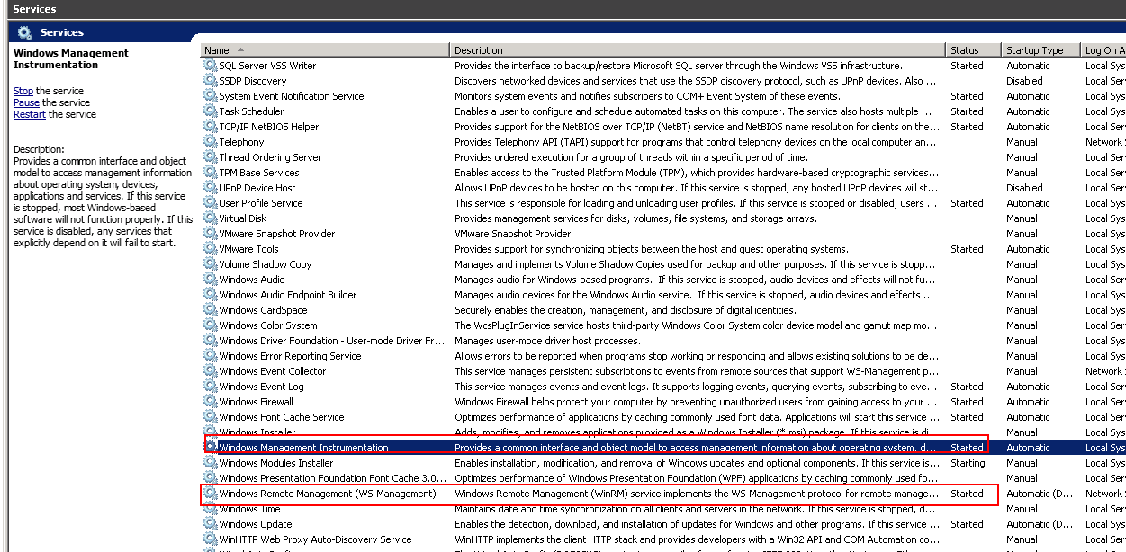

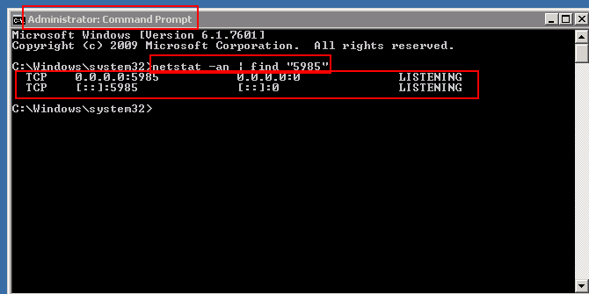

11_Error Unknown security using Remote PSSession CredSSP – see the setspn.exe suggestions at the bottom of the link below.
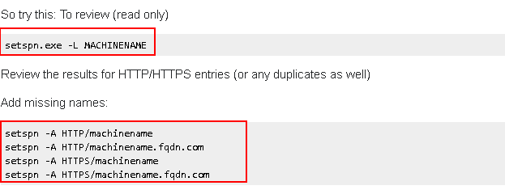
http://stackoverflow.com/questions/13271394/error-unknown-security-using-remote-pssession-credssp

12_Some access denied errors can be resolved by adding the following registry key called “Environment” under the “HKEY_CURRENT_USER” hive.
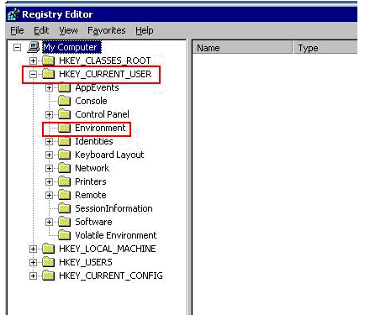
http://dea.nbird.com.au/2013/12/20/powershell-object-reference-not-set-to-an-instance-of-an-object/

13_For connection problems that relate to ipremote proxy errors, these errors can sometimes be resolved by the CSI Focal. These errors can indicate:

A) DNS issue on the jumphost or

B) The IPwin server(s) was\were not setup correctly in ipcmdb – i.e. possibly an incorrect fqdn or ip?

C)A temporary work around solution could be for the CSI focal to add the following ipwin server information to the account's PSR windows connections. The following would be required.....ipwin ip address, local ipwin id, the ip locksmith index number for the SSH JB Keys, and then select the BY_IPLOCKSMITHV2_ID in the dropdown menu.

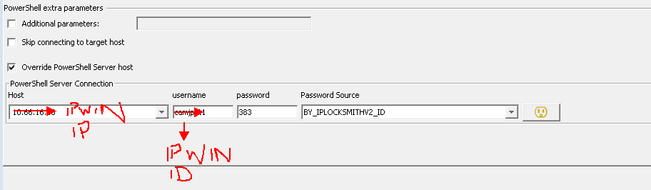

14_Run the following powershell command below to see when this server was last rebooted. If the server has been up for a while, then the SA may want to initiate the process to reboot the endpoint.
$LastSystemBoot=net stats srv | where {$_ -match "since"}; $lastsystemboot
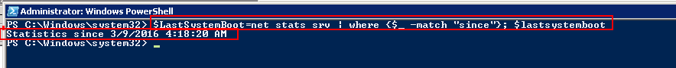

15_If you encounter the following error message (below in Red), then it’s possible that the CSI FOCAL may have to temporarily modify the PSR CONNECTION for troubleshooting purposes only. This should Not be a permanent connection change. The temporary change is to include an "additional parameter" and see if the “problem server(s)” connect with the noprofile setting. The original error is in red below and the "additional parameter" that may be required is highlighted in blue below. If this temporary setting works, then the account SA should troubleshoot the endpoint and determine why we can only connect with noprofile. The issue may be resolved by deleting our VE AD UserId profile on the “problem” endpoint server(s) in question..
Connect failed to '157.241.163.47:22' for connection '10.108.92.11 (override jumphost1_ipwin1_varid_varpass) (FQDN) / PSR (ID: 615)'. Cause: SSHClientException: Error creating the remote remote session to 10.108.92.11. Details: New-PsSession : [10.108.92.11] Connecting to remote server 10.108.92.11 failed with the following error message : <f:WSManFault xmlns:f="http://schemas.microsoft.com/wbem/wsman/1/wsmanfault" Code="2147749890" Machine="10.108.92.11"><f:Message></f:Message></f:WSManFault> For more information, see the about_Remote_Troubleshooting Help topic. At line:1 char:16 + $session_117 = New-PsSession -Credential $mycreds -Computername 10.108.92.11 +
-sessionoption (new-pssessionoption -nomachineprofile)
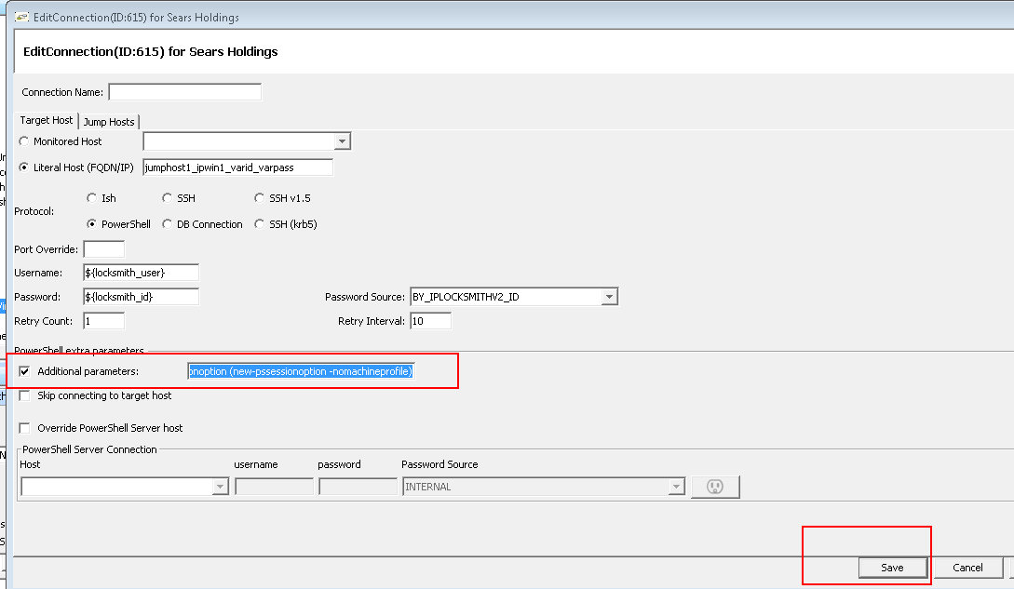

16_If you encounter a network port issue AND the "winrm quickconfig" command was successfully executed on the server endpoint in question AND there is NO firewall or network issue between the jumpbox \ ipwin server and the endpoint, then you can run the following DOS commands below to troubleshoot if the winrm port is tied to a specific ip address:
netstat -an | find "5985"
If the command above shows this port (port 5985) is only tied to an ip address other than the one the DA team is using to test, then the SA will need to ensure that the correct ip address is added by using the command below.
nestsh http add iplisten < IP address>
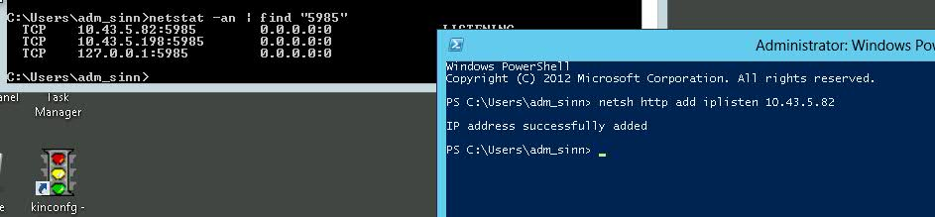

17_If you cannot successfully start the Windows Remote Management (WINRM) service, then check the following…..

This issue can happened if the NETWORK SERVICE account that the service runs under does not have rights to "Generate Security Audits" policy.

Workaround:
Navigate to “ Security settings \ local policies \ users rights assignment“
Double click “generate security audits” and add “NETWORK SERVICE” account into the list.

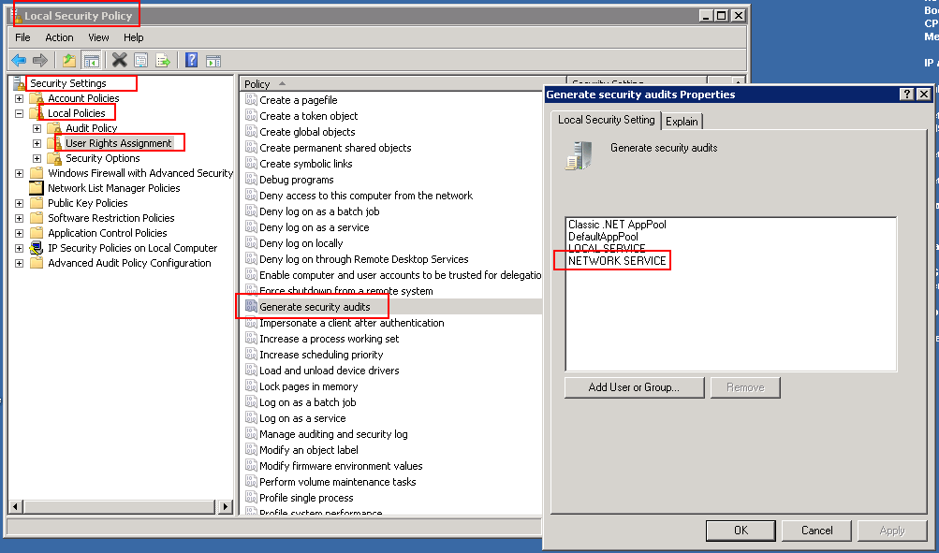
https://social.technet.microsoft.com/Forums/office/en-US/8f9b13a9-9026-42e2-8d78-c71c5ab47d83/windows-remote-management-service-error?forum=winservergen

18) For servers that are connecting okay but experience an issue with WMI calls (see snapshot below), then there is possibly an error with the WMI repository. See the suggested procedure below. Regarding the WMI repository actions, the link pasted below offers some suggested steps (in a certain order) and some warnings are noted if a rebuild procedure has to be performed. The SA should review this before executing.

First the SA can try to simply restart the WMI service and see if that resolves the issue. Additional possible solution(s) are listed below – see the link.

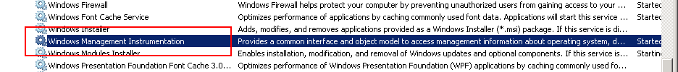

https://blogs.technet.microsoft.com/askperf/2009/04/13/wmi-rebuilding-the-wmi-repository/

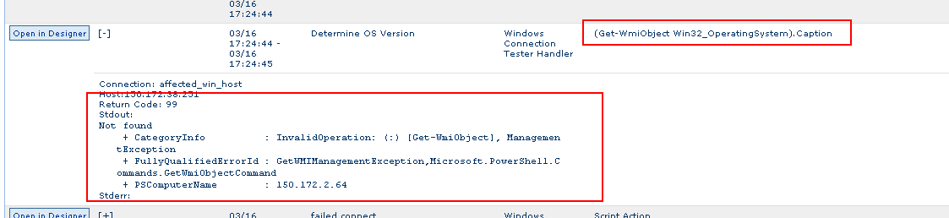

19) WINRM errors noted below could be possibly related to a firewall setting or lack thereof:

WinRM QuickConfig fail with Error number -2147024894 0x80070002 The system cannot find the file specified

Launch the “Windows Firewall with Advanced Security” applet.
Once open, click the Inbound Rules on the upper left pane
Next, check for the following rule “Windows Remote Management (HTTP-In)”
If the above rule does NOT exist, then create one and try to run the winrm quickconfig command again.
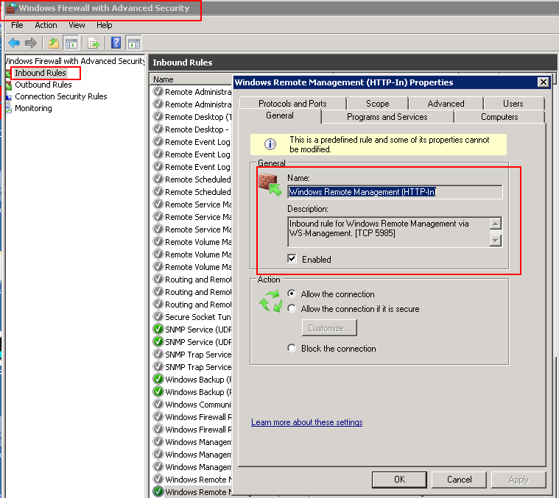

20) Ensure there are No Group Policies in place preventing powershell remote connections (error message below).

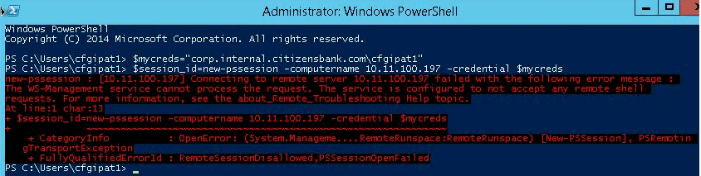
To narrow down the connectivity issue, request the account SA to login to the test server (end point) and check the WinRM shell access settings. The results may point you to the possible root cause for failing remote connections

Command: dir wsman:\localhost\shell
Output:
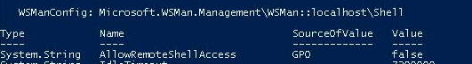

Inference: There is a group policy setting being applied on the test server that does NOT Allow Remote Shell Access.

Solution Proposed: Create a new GPO to test connections:
a. Create a new GPO that set's the value for AllowRemoteShellAccess to be TRUE and apply it on the target server. Apply the policy as Enforced if required.
b. Check that value for AllowRemoteShellAccess after the policy is applied.
c. Try connecting to the test server remotely and executing any command like hostname.
d. If the test is successful, the GPO can be applied either to the parent OU or in case a limited number of servers are to be governed remotely, the new GPO in place can be applied only to those specific servers.

NOTE: Group Policy setting for AllowRemoteShellAccess can be found under: Computer Configuration / Policies / Windows Components / Windows Remote Shell

REFERENCES:

Uninstall Previous Versions of Windows PowerShell and Windows Remote Management
https://technet.microsoft.com/en-us/library/dd351188%28v=exchg.141%29.aspx#WinRMLegacy

Installation and Configuration for Windows Remote Management
https://msdn.microsoft.com/en-us/library/aa384372%28v=vs.85%29.aspx

Update for Windows Server 2003 (KB968930)
https://www.microsoft.com/en-us/download/details.aspx?id=4045

Update for Windows Server 2003 x64 Edition (KB968930)
https://www.microsoft.com/en-us/download/details.aspx?id=10512

